Whole-genome characterisation of Escherichia coli isolates from older women with urinary tract infection or asymptomatic bacteriuria

Marlies Mulder
Manu P Bilsen, Department of Infectious Diseases, Leiden University Medical Center
Martha T van der Beek, Department of Medical Microbiology, Leiden University Medical Center
Daan/Casper??
Antoni P.A. Hendrickx, National Institute for Public Health and the Environment (RIVM), Centre for Infectious Disease Control, Bilthoven, the Netherlands.
Merel M C Lambregts Department of Infectious Diseases, Leiden University Medical Center
Caroline Schneeberger-van der Linden Nivel, Infectious Diseases in Primary Care, Otterstraat 118, Utrecht, The Netherlands

Zoiets?

Abstract
Introduction: Diagnosing urinary tract infection (UTI) in older women is complicated due to the high prevalence of asymptomatic bacteriuria (ASB). Our primary aim was to evaluate whether pathogen-related factors differ between older women with UTI and ASB. Additionally, we aimed to gain more insight into the persistence of Escherichia coli in ASB and the concordance between genotypic and phenotypic resistance of these clinical stains.
Methods: In this exploratory study, stored E. coli isolates of 46 participants of a larger case-control study were analysed. This study included women aged ≥ 65 years with UTI (≥ 2 new-onset lower urinary tract symptoms, pyuria, and bacteriuria) or ASB (E. coli ≥ 10⁴ CFU/mL in 2 consecutive samples) from the community and long-term care facilities. Whole-genome sequencing was used to identify previously described putative urinary factors (PUFs), antimicrobial resistance genes, and to determine multilocus sequence typing (MLST) sequence type (ST) and Clermont phylotype. Phenotypic susceptibility was tested according to EUCAST standards.
Results: A total of 31 isolates from UTI patients and 30 paired isolates from 15 ASB patients were analysed. We found no significant differences in ST types, the number of PUFs, or Clermont phylotypes between UTI and ASB isolates. All patients in the ASB group carried genetically similar E. coli isolates in two consecutive samples (obtained within 2-4 weeks). Antimicrobial resistance in the isolates was generally low, but phenotypic resistance to beta-lactam antibiotics, aminoglycosides, and sulfamethoxazole-trimethoprim could be well inferred from the presence of specific resistance genes.
Discussion: Our study showed that patients with ASB persistently carried similar E. coli isolates. We could not demonstrate that isolates from the UTI group were different or had more virulence factors than those from the ASB group. Despite the limited sample size, our findings suggest that host susceptibility may play a role in the older female population.

Introduction
Urinary tract infections (UTIs) are among the most common infections in humans, particularly in women, making them one of the leading reasons for prescribing antimicrobial drugs. (1, 2) Older individuals are especially susceptible to developing UTIs. Diagnosing a UTI involves assessing a combination of clinical signs and symptoms, such as dysuria, frequency, urgency, suprapubic pain, pyuria, and the presence of a uropathogen in the urine often via a urine culture (ref?).
However, diagnosing UTIs in older people can be challenging for several reasons. First, they may have difficulty expressing their symptoms, particularly due to acute cognitive decline such as delirium. Second, older patients often experience chronic lower urinary tract symptoms (LUTS), including incontinence and urgency, which are not necessarily related to UTIs and can be difficult to distinguish from UTI-related complaints. (3) Finally, the prevalence of asymptomatic bacteriuria (ASB) increases with age, affecting 40-50% of older individuals in long-term care facilities.(4) ASB can be seen as/ is currently seen as a form of… colonization. Consequently, a positive urine culture—which remains the gold standard for UTI diagnosis in clinical practice—can lead to overdiagnosis of UTIs.
Why does one patient have (persistent)ASB (colonization) while another develops a UTI (infection) ? This variation could presumably be attributed to a combination of host factors and pathogen factors, however so far no useful identifiable factors have been identified (ref?). Understanding these factors is essential for accurate diagnosis, particularly because treating ASB has been shown to neither reduce mortality nor morbidity. On the contrary, treating ASB can lead to adverse effects and colonization with resistant bacteria.(5, 6)
Recently, efforts have been made to improve the diagnosis of UTIs in older women by focusing on host factors, such as exploring inflammatory biomarkers in the urine (ref?). Conversely, pathogen factors also play a role; for instance, several putative urinary factors (PUFs) in uropathogenic E. coli have been suggested as potential predictors of urovirulence. (7, 8) This was further supported by a recent study characterizing E. coli strains from patients with sepsis and septic shock, which revealed a high prevalence of virulence genes. (9)
However, little is known about the genetic differences in the most common uropathogen, E. coli, that cause of both asymptomatic (ASB) and symptomatic (UTI) bacteriuria in older women. Therefore, our primary aim was to evaluate whether pathogen-related factors differ between older women with UTI and those with ASB. Additionally, we aimed to gain more insight into the persistence of E. coli in ASB and the concordance between genotypic and phenotypic resistance of these clinical strains. This study serves as an exploratory study to investigate the future possibility to diagnose UTI using molecular analysis of E.coli isolates, including virulence potential and antimicrobial resistance prediction.

Materials and methods
Study population
This explorative study includes a subset of participants of a prior case-control study evaluating urine biomarkers in older women >65 years with UTI and ASB.(10) The original study was conducted from June 2021 until July 2022 across several hospitals, long-term care facilities (LTCF) and primary care centres. All participants with stored E. coli isolates were included in this explorative study. The participants included patients from Leiden University Medical Centre (LUMC) and patients from general practitioners and LTCF whose samples were send to the microbiology lab of the LUMC.
UTI patients were defined as having two new-onset LUTS (dysuria, frequency, urgency and/or suprapubic pain), and pyuria (defined as ≥ 10 leukocytes/µl or ≥ 5 leukocytes per high-power field or presence of leukocyte esterase), and a urine culture that yielded E. coli ≥ 10⁴ CFU/mL. Participants were classified as having ASB if they did not have LUTS, but two consecutive urine cultures (obtained 2-4 weeks apart) yielded E. coli. The study excluded patients with advanced cognitive impairment, delirium, the presence of an indwelling catheter, immunosuppressive use, antimicrobial use within 48 hours prior to inclusion, current urolithiasis, and a previous UTI in the past month.
Sample collection
Midstream urine samples were collected in sterile urine containers. According to local protocols, 10 µL of non-centrifuged urine was placed on a 5% sheep blood agar plate and a cystine–lactose–electrolyte-deficient agar plate, and incubated for one day. A culture result was deemed a monoculture if ≥ 90% of the cultured colonies were of one micro-organism. In such cases, a susceptibility pattern was determined for the specific pathogen, using VITEK2 (bioMérieux). In instances where susceptibility testing with VITEK2 failed, disk diffusion was performed.
Breakpoints were used according to EUCAST (2024?). Isolates classified as "I" (susceptible, increased exposure) were treated as susceptible, while those falling into the category of area of technical uncertainty (ATU) were classified as resistant. For ampicillin, oral breakpoints were used, whereas for cefuroxime, intravenous breakpoints were applied. Extended-spectrum beta-lactamase (ESBL) production was phenotypically confirmed by observing a ≥ 5mm difference between the disk diffusion zones of the isolate for cefotaxime (± clavulanic acid) and ceftazidime (± clavulanic acid).

Genomic analyses
Whole=genome sequencing (WGS), assembly and typing:
E. coli isolates included in this study were subjected to whole-genome-sequencing (WGS) using Illumina next generation sequencing. DNA was extracted using the DNeasy Blood & Tissue Kit (Qiagen, Hilden, Germany) and DNA libraries were prepared using Nextera DNA Flex Library Prep kit (Illumina, San Diego, CA, USA), followed by paired-end sequencing (2 x 150 bp) on the Illumina NextSeq550 platform (Illumina, USA), all according to the manufacturer’s protocols. Read quality analysis and de novo assembly was done with the Juno-assembly v2.0.2 pipeline from the National Institute for Public Health and the Environment (RIVM) (https://github.com/RIVM-bioinformatics/juno-assembly). WGS data was used for: 1) the identification of resistance genes using ResFinder (version 4.1.0) from the Center for Genomic Epidemiology.⁸ A threshold of 95% was used for identity and 60% for the minimum length for ResFinder. 2) Multilocus sequence typing (MLST), and 3) whole-genome (wg)MLST were performed to determine genetic relatedness of E. coli isolates. For wgMLST, an in-house E. coli wgMLST scheme was used as described previously.⁹ 4) the Clermont phylotype (11),. and 5) detection of 31 previously described putative uropathogenicity factors (PUFs) (≥90% identity = present) was determined using an in-house “PUFfinder”. (8)

Statistical analysis
This study was designed as a hypothesis-generating exploratory study, with most results presented descriptively. A Mann-Whitney U test was performed to investigate the difference in the number of PUFs between women with UTI and women with ASB.
Ethical considerations
The original study was approved by the regional medical ethics committee (Leiden, Den Haag, Delft, The Netherlands) and conducted in accordance with the Declaration of Helsinki. Written informed consent was obtained from all participants. All patients included in this secondary analysis provided separate consent for the use of their samples in additional studies.
Results
General characteristics of study population
The original cohort included 213 patients, of which 46 patients were included in this study, 31 patients in the UTI group and 15 patients in the ASB group. (Figure 1) Among the 31 UTI patients, 4 (12.9%) had fever (T ≥ 38°C) at the time of diagnosis. All but one ASB patient had colony counts ≥10⁵ CFU/mL in both samples. Due to an oversight, 3 samples were collected from 2 ASB patients instead of the agreed 2 samples. The ASB patients were generally older (20% 65-74, 33.3% 75-84 and 46.7% >84 years) and more frequently residing in LTCF (53.3%) compared to the patients UTI patients (41.9% 65-74, 45.2% 75-84 and 12.4% >84 years; 12.9% admitted to LTCF).
Genetic characterization of isolates
The 46 E.coli isolates belonged to 29 different sequence types (ST), with ST69, ST73 and ST141 being the most common. ST141 was more prevalent in UTI patients than in ASB patients (Supplementary table 1). Phylotyping revealed that Clermont phylotype B2 was the most common phylotype in both the UTI (17/31; 54.8%) and the ASB (10/15; 66.7%) groups (Figure 2). Two E.coli isolates from different patients clustered together. (suppl figure clustering?) Furthermore, we investigated the presence of 31 previously described PUFs (Table 1). (8) The PUFs feoB and fimH were present in all E. coli isolates, the PUFs ompT, sitA, chiuA, fyuA and irp2 were also very common. Some PUFs (e.g. cnf1, cvaC, hek, hlyA, iroN and sfaH) were more prevalent in UTI isolates, whereas others (e.g. fyuA, iha, irp2, iucc, sat and sitA) were more common in ASB-retrieved E. coli isolates. No significant difference was found in the median number of PUFs between the UTI group (median 12, IQR 9 - 19) and the ASB group (median 14, IQR 8 - 16). (Figure 2).
Persistence of E. coli in ASB
E. coli isolates from the two different samples of all 15 ASB patients had the same wgMLST group and clustered together, strongly suggesting that these patients were colonized by the same E. coli strain for at least 2-4 weeks. In one patient from whom three samples were collected, the first sample contained an E. coli strain from a different wgMLST group than the E. coli isolates in the second and third samples which were from the same wgMLST group and clustered with each other.
Phenotypic and genotypic resistance
Phenotypic antimicrobial resistance was low in both the UTI group and the ASB group. The highest resistance was observed for ampicillin (UTI group 25.8%; ASB group 26.7%), with many of these isolates were also resistant to amoxicillin-clavulanic acid (UTI-group 19.4%; ASB group 20.0%). Most of these isolates carried a bla_{TEM-1} gene. Three isolates (1 in UTI group and 2 in ASB group) were ESBL-positive, all carrying a bla_{CTX-M}. Resistance to ciprofloxacin was 9.7% in the UTI group and 20.0% in de ASB group, but this could not be linked to genotypic resistance. For aminoglycosides, genes from the aac, aad and aph-groups were found. Two isolates were resistant to the aminoglycosides tobramycin and gentamicin, both carrying an aac(3)-gene. All isolates resistant to sulfamethoxazole-trimethoprim carried a combination of a dfrA and a sul1 or sul2 gene. However, the one isolate phenotypically resistant to trimethoprim but susceptible to trimethoprim-sulfamethoxazole also carried this gene combination. No phenotypic resistance to imipenem and meropenem was found, confirmed by the absence of carbapenemase genes. Similar, no resistance was found to nitrofurantoin and fosfomycin. (Table 2)

Discussion
In this study, we characterized E.coli isolates from older female patients with UTI and ASB. The 46 E.coli isolates belonged to 29 different ST types, with ST69, ST73 and ST141 being the most common. We also investigated the presence of PUFs, but found no significant difference in their numbers between the two groups. For various PUF’s, differences may be present between UTI and ASB that warrant further investigation in larger cohort, because numbers were too small for formal conclusions. Also, we did show that E.coli isolates in the ASB group persisted for several weeks. Additionally, there was a strong concordance between phenotypic and genotypic resistance.
Diagnosing UTI, particularly in older patients, can be challenging. We explored whether characterization, such as ST type or virulence factors, could aid in diagnosis. However, we found a wide variety of ST types, with only ST 141 being more prevalent in the UTI group, although the numbers were still low. Previous studies on E. coli isolates in bloodstream infections suggest that four ST groups (ST131, ST73, ST95, and ST69) account for 38-61% of isolates. (9) We also identified isolates from all these groups, accounting for only 19% of isolates in the UTI group and 47% in the ASB group. This indicates that while these ST groups might be more common, they do not seem to play a significant role in virulence in our older population. Clustering of ST groups in specific disease types might be more related to geographical factors than disease type or virulence.
We also examined E. coli virulence factors, which have been associated with UTI isolates in previous studies. Although we found some PUFs that were more prevalent in the UTI group than in the ASB group, we also found PUFs that were more common in the ASB group. This resulted in no overall difference in the number of PUFs between the two groups. Furthermore, we demonstrated that an E. coli isolate could persist for several weeks in the ASB group, suggesting that carrying these isolates does not necessarily lead to UTI in the short term. Thus, in this study of older individuals, we could not show that particular genes or set of genes of E. coli isolate itself played a major role in the development of UTIs. This finding is consistent with another study involving 43 strains from 14 women, which concluded that the enrichment of these PUFs might be linked to the Clermont phylotype, e.g., type B2, which has been associated with UTI. (8, 14) However, we also did not find differences in the Clermont phylotype between the two groups.
Wel interessant dat S pili adhesin (percentueel) meer voorkwam bij UTI dan ASB. Dat kan natuurlijk toeval zijn, maar je kan in de discussie speculeren dat dit betekent dat isolaten bij ASB minder vaak hechten aan het uroepitheel.

Phenotypic resistance for individual antimicrobial drugs could be well predicted from genotypic resistance for the beta-lactam antimicrobials, especially for phenotypic ESBL, all of which carried CTX-M genes. Notably, the isolates phenotypically resistant to amoxicillin-clavulanic acid all carried a TEM-1 gene. Clavulanic acid is a potent inhibitor of TEM-1, but overproduction or a single amino acid change in TEM-1 can result in resistance. (15) Resistance to aminoglycosides was also well predicted, with genes from the AAC, AAD, and APH groups identified. These genes encode aminoglycoside-modifying enzymes, the most common mechanism of resistance to aminoglycosides. However, these genes have specific substrates: AAC(3) genes affect gentamicin and tobramycin (which were phenotypically tested) as well as kanamycin, but not amikacin; APH genes confer resistance to kanamycin, but not gentamicin, tobramycin, or amikacin; and AAD genes cause resistance to streptomycin and spectinomycin. (16-18) Isolates phenotypically resistant to sulfamethoxazole-trimethoprim all carried a combination of dfrA and sul1 and/or sul2 genes, although one isolate resistant to trimethoprim but not to sulfamethoxazole-trimethoprim also carried these genes. No resistance genes were found for fluoroquinolone resistance, despite some isolates being phenotypically resistant to ciprofloxacin, possibly due to resistance being mostly caused by point mutations.
This descriptive study on E. coli isolates in ASB and UTI in older patients, while limited in numbers, provides important leads for future research. It highlights the rarity of characterizing E. coli isolates, especially in older patients, as empirical treatment is more common. Furthermore, it shows that ASB patients can carry the same E. coli isolate—some of which have been linked to virulence in previous studies—for several weeks without developing UTI symptoms. We also could not demonstrate significant differences in genomic characterization of E. coli isolates between older UTI and ASB patients. This suggests that in our vulnerable population of older women, host susceptibility may be more crucial than the virulence of the E. coli isolate, or that the key virulence factors might differ depending on the age group. We hope this kind of studies will pave the way for future research to determine whether it is feasible to predict UTI versus ASB and phenotypic resistance through genotyping.

En dus misschien nog beter onderzoek doen naar
- Die interactie tussen colis en blaasepitheelcellen & adhesins
- Over de tijd grotere groepen omdat er meer WGS uitgevoerd gaat worden in de toekomst
- En heel lang werden ASB/UTI colis op 1 berg gegooid dit ook meenemen

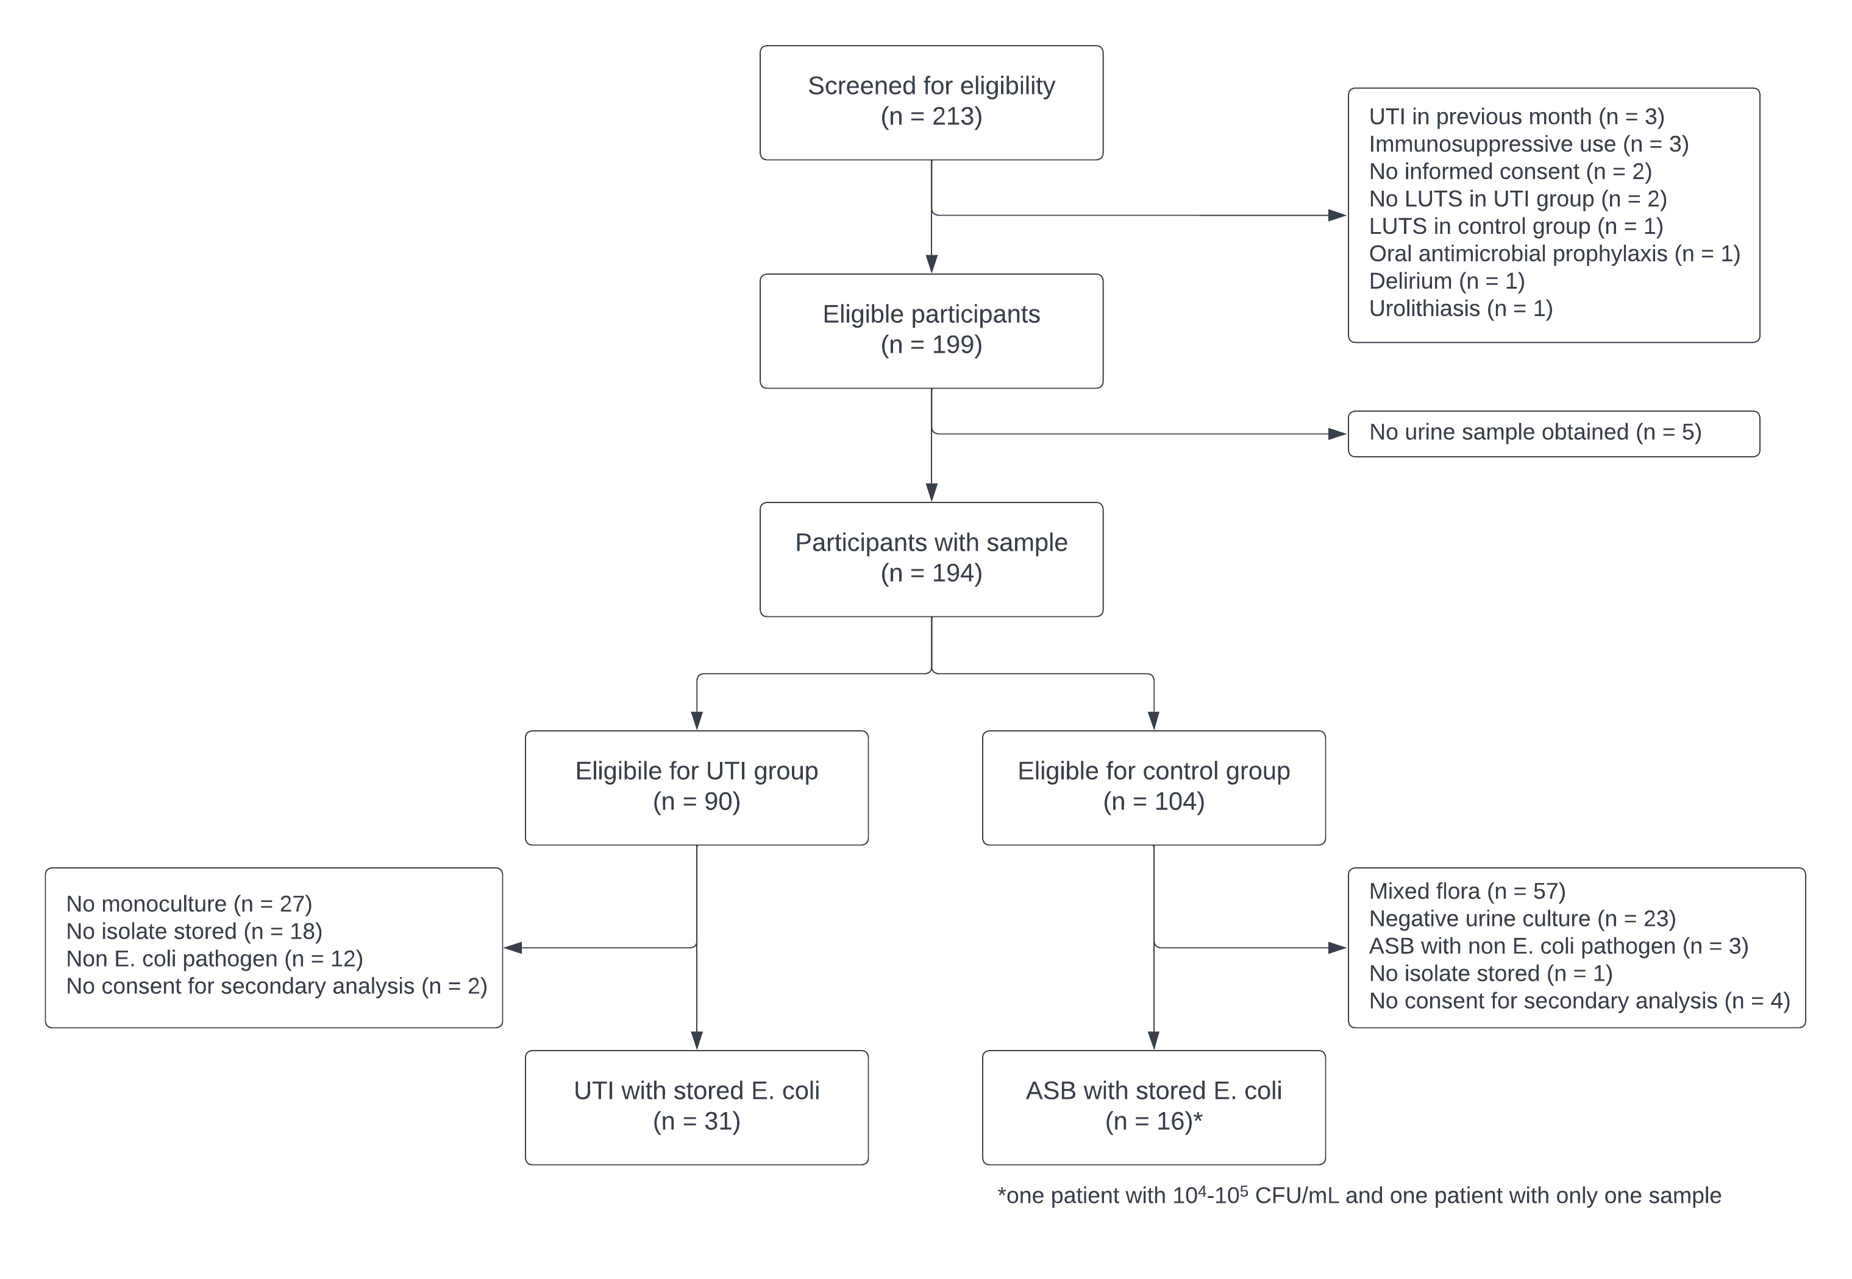
Figure 1. Flowchart of sample selection of women who fulfilled the criteria to suffer from UTI or ASB.

Supplementary table 1 ST types of E. coli isolates in UTI and ASB patients
ST type | Overall, n (%) | UTI, n (%) | ASB, n
10 | 2 (4.3) | 2 (6.5) | 0 (0)
12 | 2 (4.3) | 1 (3.2) | 1 (6.7)
59 | 2 (4.3) | 2 (6.5) | 0 (0)
69 | 4 (8.7) | 2 (6.5) | 2 (13.3)
73 | 4 (8.7) | 3 (9.7) | 1 (6.7)
88 | 1 (2.2) | 1 (3.2) | 0 (0)
91 | 1 (2.2) | 0 (0) | 1 (6.7)
95 | 3 (6.5) | 1 (3.2) | 2 (13.3)
127 | 1 (2.2) | 1 (3.2) | 0 (0)
131 | 2 (4.3) | 0 (0) | 2 (13.3)
141 | 4 8.7) | 4 (12.9) | 0 (0)
162 | 1 (2.2) | 0 (0) | 1 (6.7)
174 | 1 (2.2) | 1 (3.2) | 0 (0)
349 | 2 (4.3) | 2 (6.5) | 0 (0)
357 | 1 (2.2) | 1 (3.2) | 0 (0)
538 | 1 (2.2) | 0 (0) | 1 (6.7)
569 | 1 (2.2) | 1 (3.2) | 0 (0)
602 | 1 (2.2) | 1 (3.2) | 0 (0)
636 | 1 (2.2) | 1 (3.2) | 0 (0)
963 | 1 (2.2) | 0 (0) | 1 (6.7)
998 | 2 (4.3) | 2 (6.5) | 0 (0)
1049 | 1 (2.2) | 1 (3.2) | 0 (0)
1193 | 1 (2.2) | 0 (0) | 1 (6.7)
1444 | 1 (2.2) | 1 (3.2) | 0 (0)
2521 | 1 (2.2) | 1 (3.2) | 0 (0)
4360 | 1 (2.2) | 1 (3.2) | 0 (0)
5420 | 1 (2.2) | 0 (0) | 1 (6.7)
8464 | 1 (2.2) | 1 (3.2) | 0 (0)
undefined | 1 (2.2) | 0 (0) | 1 (6.7)

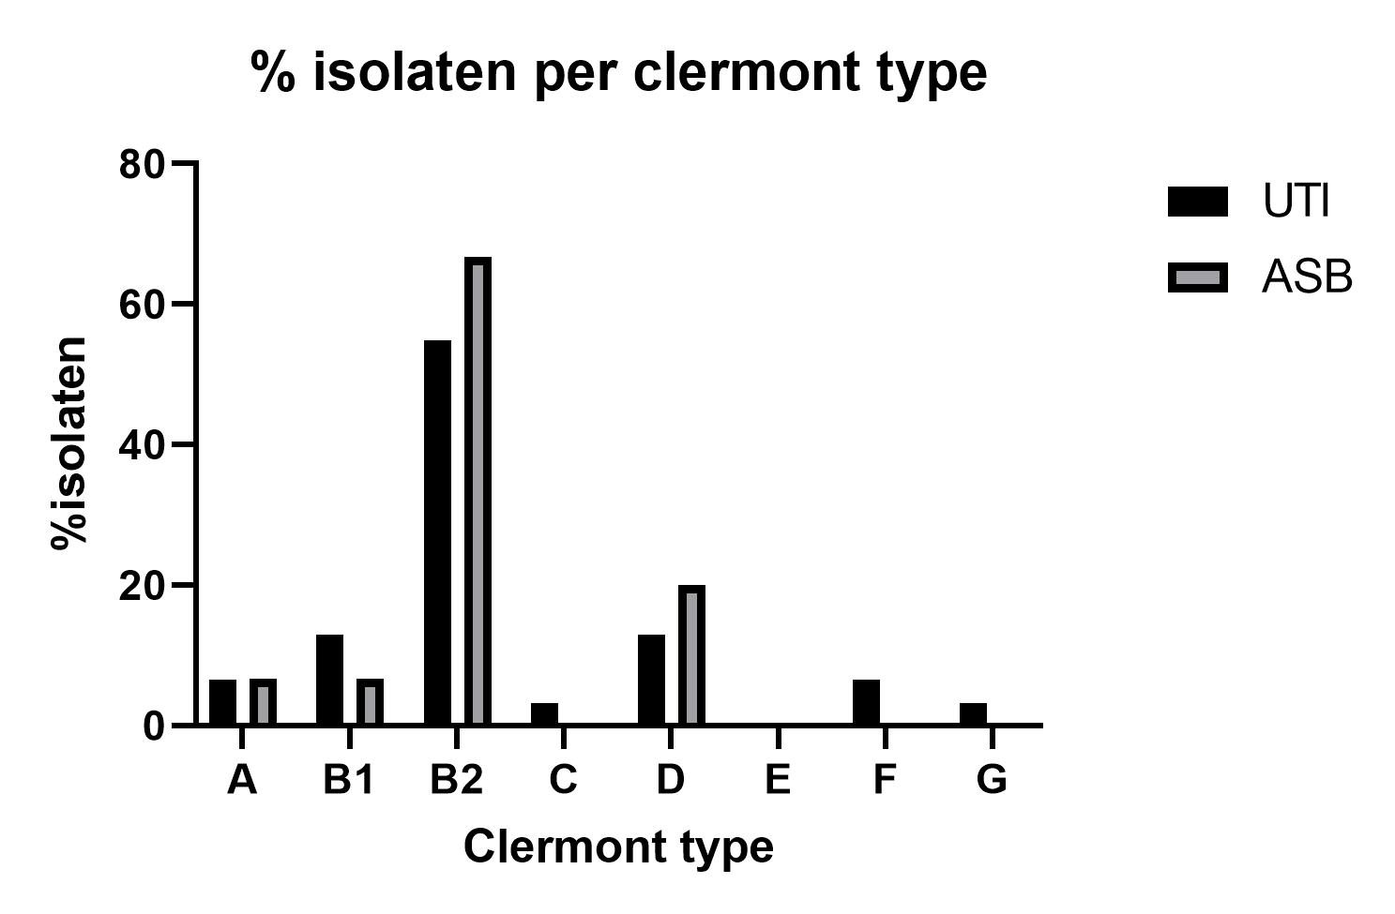
Figure 2: Percentage of isolates per Clermont phylotype.

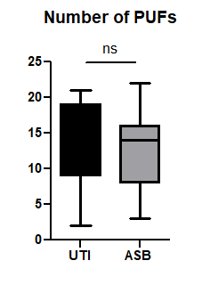
Figure 3: Number of putative uropathogenicity factors in E. coli isolates from the patients with urinary tract infection (UTI) and asymptomatic bacteriuria (ASB).
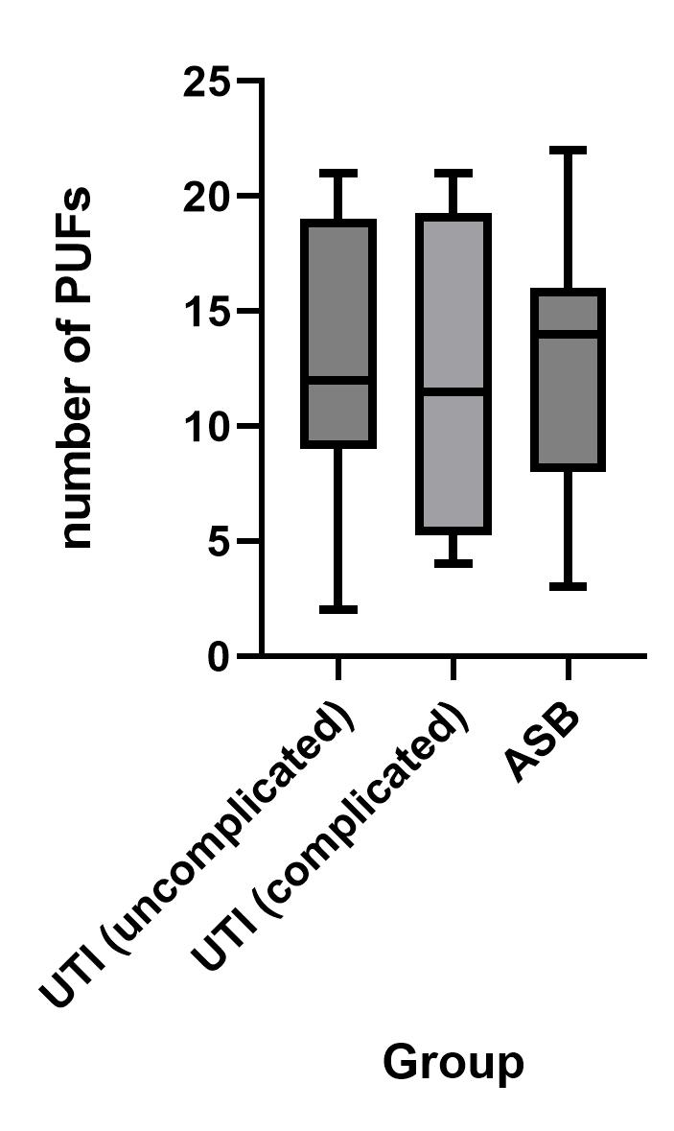
Ter info hier een onderscheid tussen wel geen koorts, maar het zijn maar 4 mensen met koorts en er is geen onderscheid dus het leek met niet per se iets om te laten zien.

Table 1. Percentages of isolates with the PUFs in the UTI and ASB group
PUF abbreviation | PUF description | Overall, n (%) | UTI group, n (%) | ASB group, n (%)
bmaE | Blood group M-specific adhesin | 0 (0) | 0 (0) | 0 (0)
cdtB | Cytolethal distending toxin | 1 (2) | 1 (3) | 0 (0)
chuA | Heme binding outer membrane | 37 (80) | 24 (77) | 13 (87)
cnf1 | Cytotoxic necrotizing factor 1 (toxin) | 12 (26) | 10 (32) | 2 (13)
cvaC | Colicin V | 6 (13) | 5 (16) | 1 (7)
draB | Dr antigen-specific adhesin | 0 (0) | 0 (0) | 0 (0)
feoB | Ferrous iron transport | 46 (100) | 31 (100) | 15 (100)
fimH | D-mannose–specific adhesin, lining the superficial bladder epithelium. | 46 (100) | 31 (100) | 15 (100)
focH | F1C pili adhesin | 12 (26) | 9 (29) | 3 (20)
fyuA | Yersiniabactin siderophore receptor | 36 (78) | 23 (74) | 13 (87)
hek | Auto-aggregating adhesin and invasin | 17 (37) | 13 (42) | 4 (27)
hlyA | a-Hemolysin (toxin) | 14 (30) | 11 (35) | 3(20)
ibeA | Invasion of brain endothelium | 10 (22) | 7 (23) | 3 (20)
iha | Nonhemagglutinin adhesin | 10 (22) | 4 (13) | 6 (40)
ireA | Iron-regulated element (siderophore receptor) | 4 (9) | 3 (10) | 1 (7)
iroN | Salmochelin siderophore receptor | 23 (50) | 17 (55) | 6 (40)
irp2 | Yersinia biosynthetic protein | 36 (78) | 23 (74) | 13 (87)
iucc | Aerobactin biosynthetic protein | 14 (30) | 7 (23) | 7 (47)
iutA | Ferric aerobactin receptor | 4 (9) | 3 (10) | 1 (7)
malX | Marker of pathogenicity-associated island | 29 (63) | 19 (61) | 10 (67)
ompT | Outer membrane protein T (protease) | 39 (85) | 25 (81) | 14 (93)
papG2 | P pili adhesin - Pyelonephritis-associated papG variant | 16 (35) | 11 (35) | 5 (33)
PapG3 | P pili adhesin - Cystitis-associated papG variant | 16 (35) | 11 (35) | 5 (33)
picU | Protein involved in Intestinal Colonization - serine protease | 8 (17) | 6 (19) | 2 (13)
sat | Secreted autotransporter toxin | 9 (20) | 4 (13) | 5 (33)
SfaH | S pili adhesin (marker for sfa operon) | 11 (24) | 10 (32) | 1 (7)
sitA | Periplasmic iron transport | 38 (83) | 24 (77) | 14 (93)
traT | Temperature-sensitive hemagglutinin - serine protease | 21 (46) | 13 (42) | 8 (53)
tsH | Surface exclusion (toxin) | 26 (57) | 18 (58) | 8 (53)
usp | Uropathogenic-Specific Protein (bacteriocin) | 30 (65) | 20 (65) | 10 (67)
vat | Vacolating autotransporter - serine protease (toxin) | 26 (57) | 18 (58) | 8 (53)

Table 2. Phenotypic and genotypic resistance
 | Overall, n (%) | UTI, n (%) | ASB, n (%) | Genes
 | (n = 46) | n (=31) | n (=15)
ampicilline | 12 (26.1) | 8 (25.8) | 4 (26.7) | 10/12 TEM-1
augmentin | 9 (19.6) | 6 (19.4) | 3 (20.0) | 9/9 TEM-1
cefuroxime | 5 (10.9) | 3 (9.7) | 2 (13.3) | 3/5 CTX-M
3rd generation cephalosporins* | 3 (6.5) | 1 (3.2) | 2 (13.3) | 3/3 CTX-M
imipenem | 0 (0) | 0 (0) | 0 (0) | -
meropenem | 0 (0) | 0 (0) | 0 (0) | -
ciprofloxacine | 6 (13.0) | 3 (9.7) | 3 (20.0) | -
aminoglycosides** | 2 (4.3) | 1 (3.2) | 1 (6.7) | 2/2 aac3
trimethoprim | 8 (17.4) | 6 (19.4) | 2 (13.3) | 8/8 dfrA (and sul1 and/or sul2)
cotrimoxazol | 7 15.2) | 5 (16.1) | 2 (13.3) | 7/7 dfrA and sul1 and/or sul2
nitrofurantoine | 0 (0) | 0 (0) | 0 (0) | -
fosfomycine | 0 (0) | 0 (0) | 0 (0) | -

* ESBL positive
** both gentamicin and tobramycin were tested and resistant in both cases

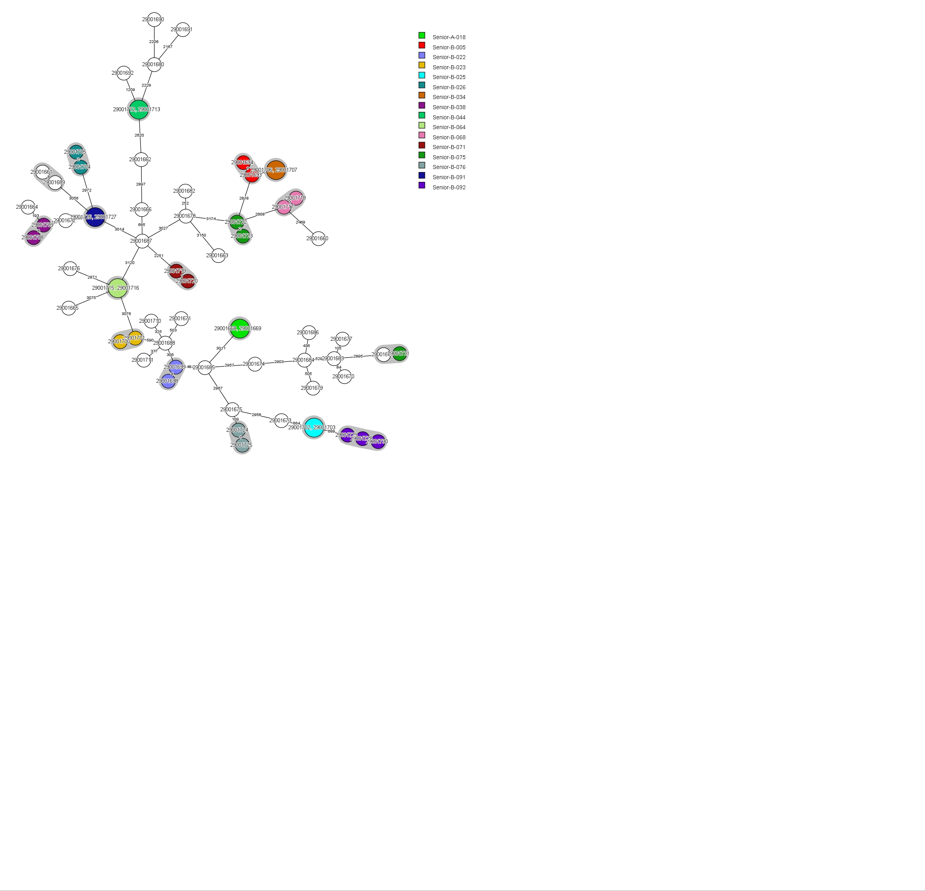
Figure 4: wgMLST-based minimum spanning tree of E. coli isolates analysed in this study. A genetic cluster is defined as ≥2 E. coli isolates varying ≤25 wgMLST alleles and can be regarded the same strain. Grey halo indicates genetic clusters, while other colours depict different patients.

Evt nog UTI vs ASB aankleuren?

References
1. Foxman B. The epidemiology of urinary tract infection. Nat Rev Urol. 2010;7(12):653-60.
2. Mulder M, Baan E, Verbon A, Stricker B, Verhamme K. Trends of prescribing antimicrobial drugs for urinary tract infections in primary care in the Netherlands: a population-based cohort study. BMJ Open. 2019;9(5):e027221.
3. Irwin DE, Milsom I, Hunskaar S, Reilly K, Kopp Z, Herschorn S, et al. Population-based survey of urinary incontinence, overactive bladder, and other lower urinary tract symptoms in five countries: results of the EPIC study. Eur Urol. 2006;50(6):1306-14; discussion 14-5.
4. Rowe TA, Juthani-Mehta M. Urinary tract infection in older adults. Aging health. 2013;9(5).
5. Nicolle LE, Mayhew WJ, Bryan L. Prospective randomized comparison of therapy and no therapy for asymptomatic bacteriuria in institutionalized elderly women. Am J Med. 1987;83(1):27-33.
6. Abrutyn E, Berlin J, Mossey J, Pitsakis P, Levison M, Kaye D. Does treatment of asymptomatic bacteriuria in older ambulatory women reduce subsequent symptoms of urinary tract infection? J Am Geriatr Soc. 1996;44(3):293-5.
7. Johnson JR, Owens K, Gajewski A, Kuskowski MA. Bacterial characteristics in relation to clinical source of Escherichia coli isolates from women with acute cystitis or pyelonephritis and uninfected women. J Clin Microbiol. 2005;43(12):6064-72.
8. Schreiber HLt, Conover MS, Chou WC, Hibbing ME, Manson AL, Dodson KW, et al. Bacterial virulence phenotypes of Escherichia coli and host susceptibility determine risk for urinary tract infections. Sci Transl Med. 2017;9(382).
9. Maldonado N, Lopez-Hernandez I, Garcia-Montaner A, Lopez-Cortes LE, Perez-Crespo PMM, Retamar-Gentil P, et al. Whole-genome characterisation of Escherichia coli isolates from patients with bacteraemia presenting with sepsis or septic shock in Spain: a multicentre cross-sectional study. Lancet Microbe. 2024;5(4):e390-e9.
10. Bilsen MP, Treep MM, Aantjes MJ, van Andel E, Stalenhoef JE, van Nieuwkoop C, et al. Diagnostic accuracy of urine biomarkers for urinary tract infection in older women: a case-control study. Clin Microbiol Infect. 2023.
11. Clermont Typing [Available from: http://clermontyping.iame-research.center/index.php.
12. Notermans DW, Schoffelen AF, Landman F, Wielders CCH, Witteveen S, Ganesh VA, et al. A genetic cluster of OXA-244 carbapenemase-producing Escherichia coli ST38 with putative uropathogenicity factors in the Netherlands. J Antimicrob Chemother. 2022;77(11):3205-8.
13. Hendrickx APA, Landman F, de Haan A, Witteveen S, van Santen-Verheuvel MG, Schouls LM, The Dutch Cpe Surveillance Study G. bla(OXA-48)-like genome architecture among carbapenemase-producing Escherichia coli and Klebsiella pneumoniae in the Netherlands. Microb Genom. 2021;7(5).
14. Ciesielczuk H, Jenkins C, Chattaway M, Doumith M, Hope R, Woodford N, Wareham DW. Trends in ExPEC serogroups in the UK and their significance. Eur J Clin Microbiol Infect Dis. 2016;35(10):1661-6.
15. Stapleton P, Wu PJ, King A, Shannon K, French G, Phillips I. Incidence and mechanisms of resistance to the combination of amoxicillin and clavulanic acid in Escherichia coli. Antimicrob Agents Chemother. 1995;39(11):2478-83.
16. Garneau-Tsodikova S, Labby KJ. Mechanisms of Resistance to Aminoglycoside Antibiotics: Overview and Perspectives. Medchemcomm. 2016;7(1):11-27.
17. Mancini S, Marchesi M, Imkamp F, Wagner K, Keller PM, Quiblier C, et al. Population-based inference of aminoglycoside resistance mechanisms in Escherichia coli. EBioMedicine. 2019;46:184-92.
18. Sandvang D. Novel streptomycin and spectinomycin resistance gene as a gene cassette within a class 1 integron isolated from Escherichia coli. Antimicrob Agents Chemother. 1999;43(12):3036-8.

Info over aminoglycoside genen:
aac(3)-IId* | aadA2 | aadA2b* | aadA5 | aph(3'')-Ib | aph(3'')-Ib* | aph(3'')-Ib? | aph(3')-Ia | aph(6)-Id
Aminogl  g/t/k | Aminogl  Str/sp | Aminogl  Str/sp | Aminogl  spectinomycin | Aminogl  k | Aminogl  k | Aminogl  k | Aminogl  k | Aminogl  k
a
APH(3′) affects kanamycin but not gentamicin, tobramycin and amikacin.
b
AAC(3) affects gentamicin, tobramycin, kanamycin but not amikacin.
c
AAC(6′) affects amikacin, kanamycin, tobramycin but not gentamicin.

